Jenkins Documentation

Step1: commit file or Folder through svn.

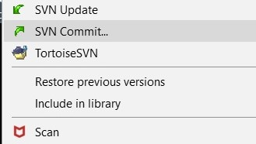

Step2: Go to Jenkins Dash Board and run build for Respective Environment.

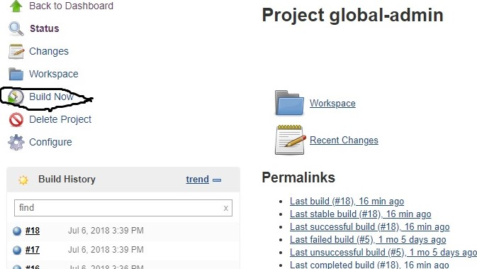Step3: Now files gets move on Svn.

Step4: Now Execute run. Php file from the local host. In php file add your old/new files.

Step5: copy Build.xml/Deploy.xml files into Folder.

Step6: Now go to Jenkins Dashboard. Choose Global-admin.

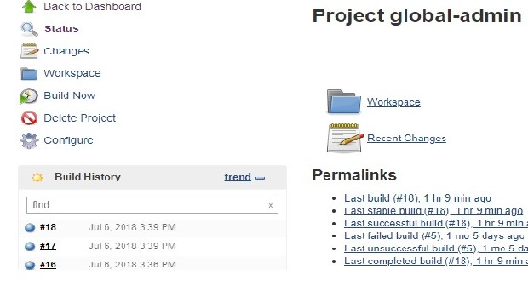

Step7: Now use the build now option.



Step8: Now you Build on 10 server.

Step9: Now go to Jenkins Dash Board and choose production-design-development.

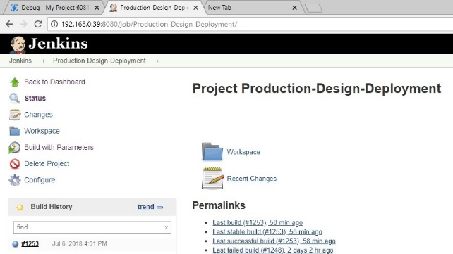

Step10: Now choose Build with parameters.

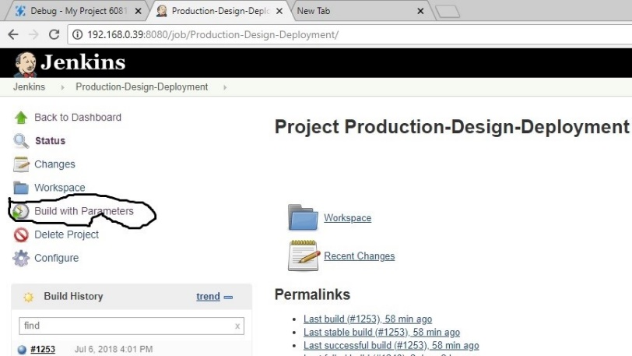

Step11: Now give build name, deploy name and choose environment.

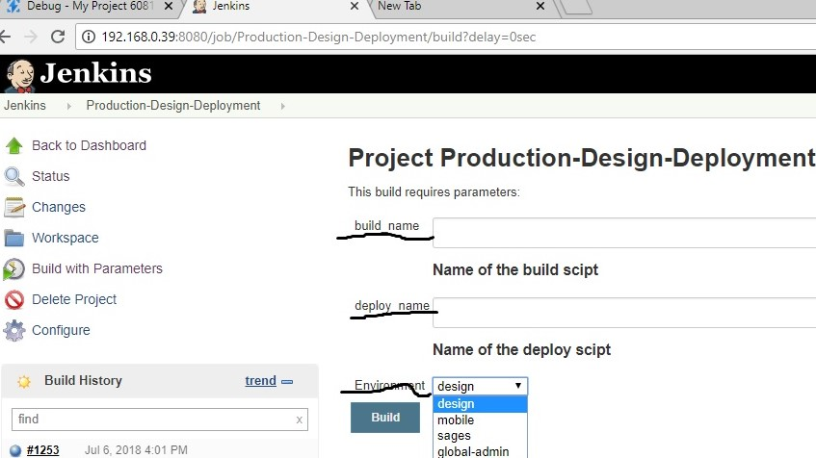

Step12: Now click on build option.

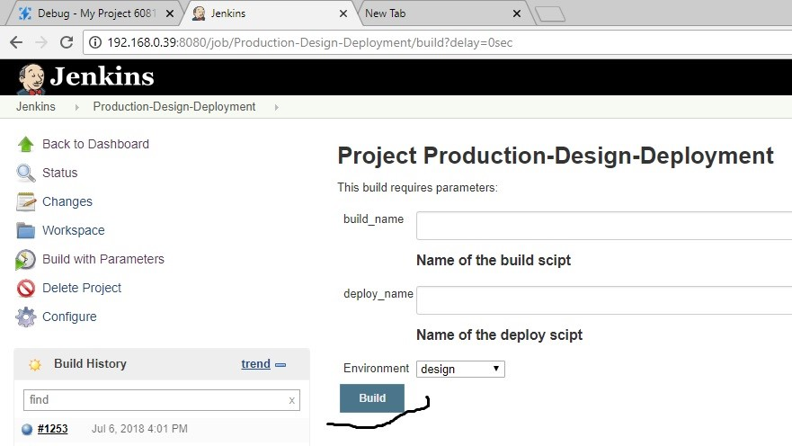

Step13: Now file is executed.

Step14: Now files get move on live server which we chosen environment.

Step15: suppose we revert the live server files. Go to Jenkins dash board select Production-Revert.

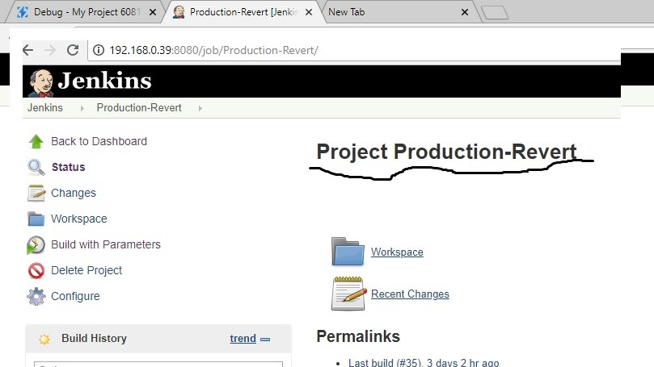

Step17: Now click on Build with Parameters and give build name and choose environment and click on build.

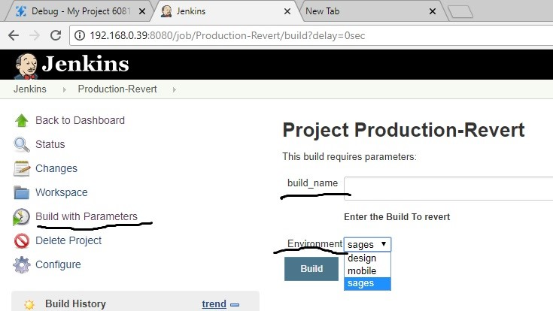

Step18: Now the file is revert.

Note: Currently we are using in Jenkins dash board projects are

1) Dev-Builds

2) Dev-Ndesign-update

3) Dev-sagesurfer.com

4) Global-Admin

The above 4 are using for Development.

5) Production-Design-Deployment:

It is used for production.

6) Production-Revert:

It is used for to revert the application.